Ex. No. : 03 Date: 23/02/2026
Register No.: 231701030 Name: V.J.LAKSHNAN

Wire framing and Prototyping with Figma

Aim
To design and develop a native Android application using Kotlin that provides real-time ecommerce customer insights through interactive dashboards, smart filtering, and visual analytics, enabling data-driven decision-making for stakeholders.

Procedure:

The app is a mobile-based analytics platform that transforms ecommerce transactional data into meaningful insights using modern Android technologies. Below is the core user flow based on the project:
User Flow
• Launch the Android application to view a real-time dashboard displaying key metrics like total orders, revenue, and customer segments.
• Interact with dynamic dashboards that include bar charts, pie charts, and line graphs for visualizing trends and performance.
• Apply smart filters such as date range, customer segment, region, and product category to refine insights instantly.
• Explore detailed reports with smooth touch interactions and real-time updates using native chart rendering.
• Export filtered data as CSV files or share visual reports directly from the application.
• Data is managed using Room Database and processed efficiently using Kotlin Coroutines and StateFlow for smooth performance.
This flow ensures fast, interactive, and efficient data analysis using a clean architecture and modern Android development practices.

Output
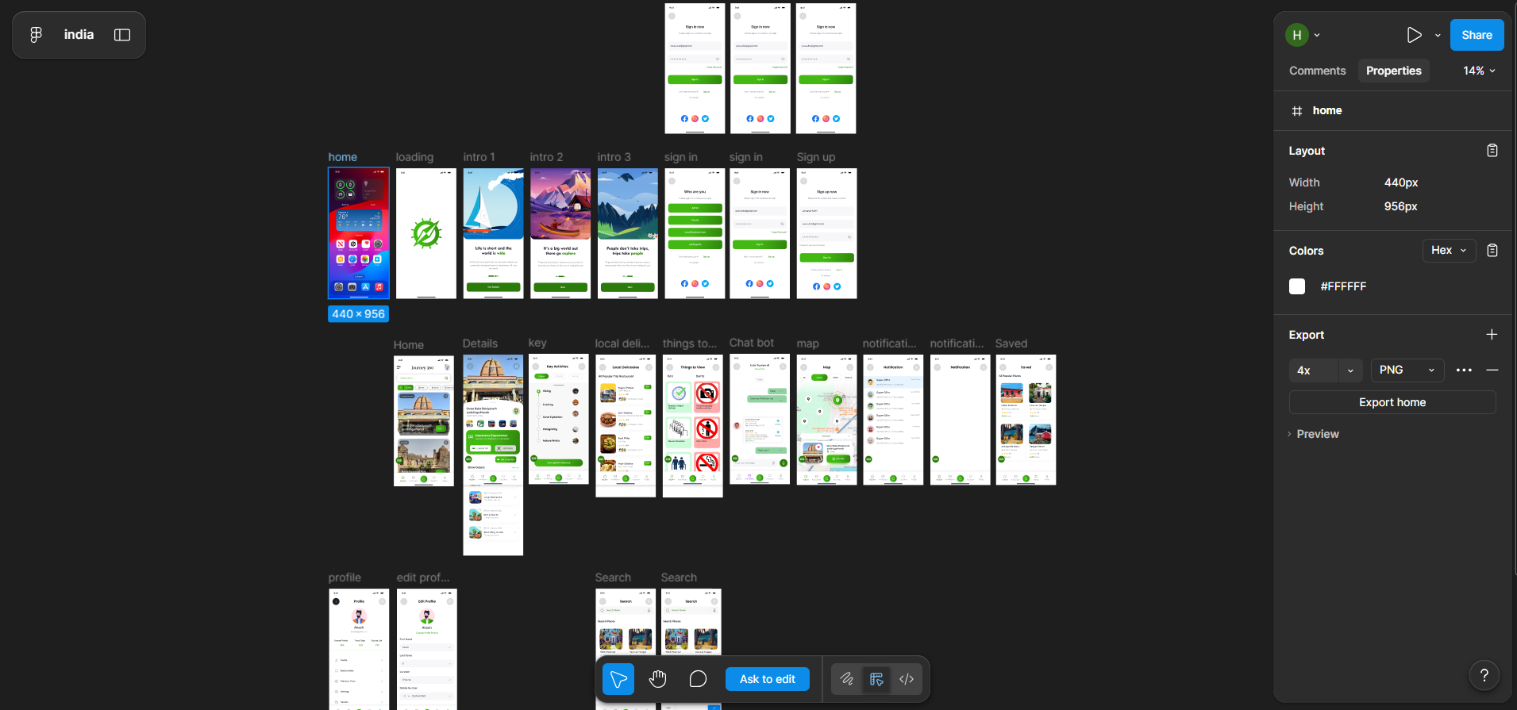

Result:
Hence the experiment is completed and the output is verified.

